Louise’s analysis of metacetamol form 2
Shihao identified 4 structures, 124, 395, 7255 and 131, that shared a common sheet with metacetamol form 2 (MENSEE04). These do indeed share a common layer, matching the number of molecules and RMSD reported by Shihao (See original Table below, in Sally’s comments.)
Looking at this sheet within the structures, it can be viewed as having a direction. All the alcohol groups at the top of the central sheets in Figure 1 point to the right (the bottom groups point to the left). In the four hypothetical structures, the adjacent sheets are the same, with inversion centres between the sheets. The reported structure of form 2 has the adjoining sheets oppositely arranged, and no symmetry elements between the layers.
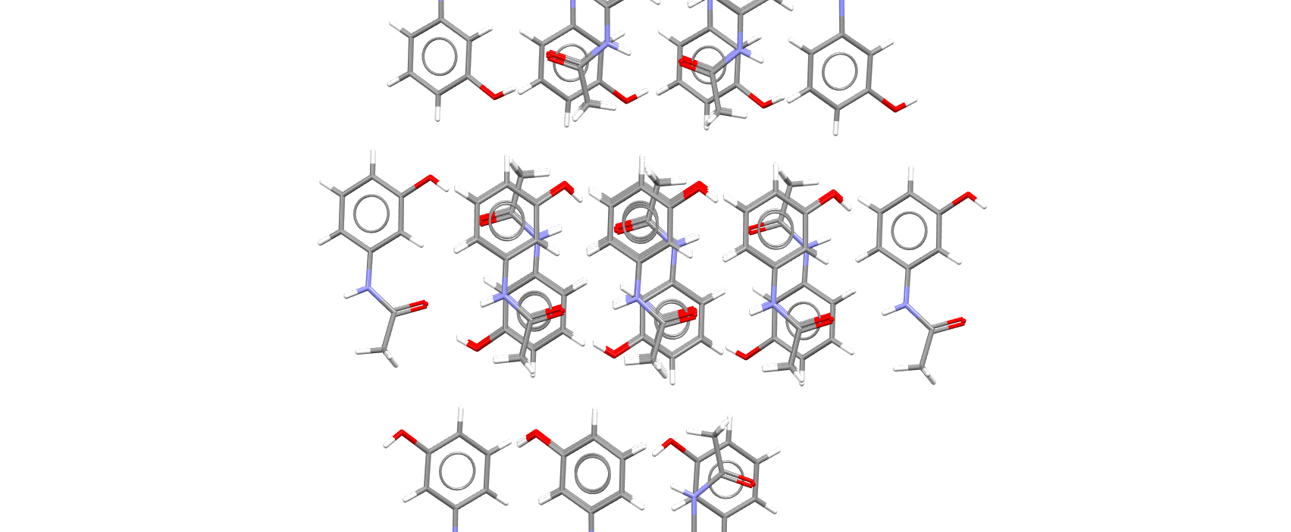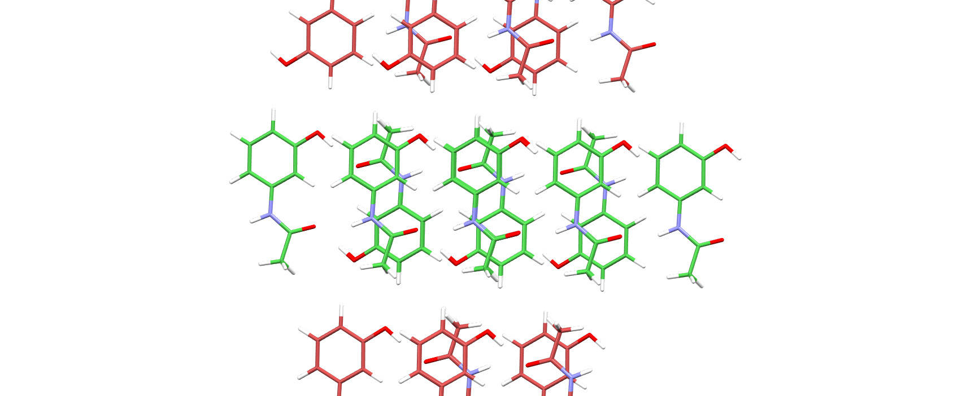
Figure 1. View of the sheets in metacetamol form 2 (left; coloured by element) and 124 (right, green/red carbon atoms).
Running a crystal packing feature search on the structures numbered under 10000 also found structures 974, 1013 and 7273 contained this sheet. 974 and 1013 match 18 out of 30 molecules, while 7273 reportedly matches 30 although these are all in the same sheet. The a cell length is 79 Å whereas the b length in form 2 is only 19 Å, which spans 2 layers. This shows that the weak dispersion binding between layers does not necessarily hold the structure together.
The angle C_{ring}_C_{ring}_N_C(=O) in MENSEE04 (first molecule only; Shihao showed the conformations were nearly identical) is 30.18° while in 124 it is 18.39°, 131 is 17.16°, 395 is 17.38° and 7255 is 19.64°.

Summary
This sheet is weakly bonded, and can stack either way up (need to check whether any hypotheticals stack antiparallel). It is so weakly bound that it can easily come apart (susceptible to shear?) (propensity for solvate formation with apolar solvents?).

Sally’s comments:
Above is Louise Price’s check on the CSP performed and reported by Shihao Ying for his recently submitted MSc dissertation. Looking up the calculated energies, it seems that Shihao correctly identified the lower energy structures in the Z’=1 search that had significant similarity to form II, and are not much higher in energy.
Form II is Z’=2, so it was not found in the CSP, but with the same energy model, optimised form II has a lattice energy of -118.56 kJ/mol. The lack of symmetry elements relating the sheets of form II is allowed by it being a Z’=2 structure. Hence a Z’=2 search might find other stackings that are more stable than those generated by Shihao. The additional structures identified by Louise are even higher in energy, but the structure that has the sheets widely separated (7273) shows that the interaction between the layers contributes less than 18.5 kJ/mol to the lattice energy. The relative lattice energies are likely to be very dependent on the dispersion model in any periodic electronic structure calculation or other method of estimating the lattice energy.

Original Table from Shihao’s thesis, with addition of extra structures identified by Louise, and lattice energies added by Sally.
Reference for RMSDn | CSP structure  Rank-number | Number of molecules matched ≤30 by Mercury, default | RMSDn/Å | Elatt kJ/mol
MENSEE04 | 11-124 | 14 out of 30 | 0.243 | -117.24
MENSEE04 | 17-395 | 13 out of 30 | 0.232 | -116.82
MENSEE04 | 21-7255 | 14 out of 30 | 0.238 | -116.08
MENSEE04 | 31-131 | 13 out of 30 | 0.246 | -115.45
Extras | 223-974 | 18 out of 30 |  | -111.53
 | 398-1013 | 18 out of 30 |  | -109.04
 | 1070-7273 | 30 but only sheet |  | -100.04

